The Reduction of Clinical Symptoms Commonly Associated with Opioid Withdrawal Utilizing Peri-Auricular Percutaneous Nerve Field Stimulation( PENFS )

Arturo Taca , MD *

Abstract

Key areas of the brain and brainstem which are normally responsible for homeostasis are typically suppressed by opiates altering both function and the ability to adapt. Upon removal of the opiates these areas typically respond by becoming hyperactive for a period of time before returning to homeostasis. The physical components commonly associated with opioid withdrawal is a result of the complex interaction of biological feedback loops influenced by the autonomic nervous system. Peri-auricular percutaneous electrical nerve field stimulation (PENFS) using the Bridge © (Innovative Health Solutions, Versailles, IN) is an efficacious way to help reduce symptoms often associated with opioid withdrawal by stimulating areas of the brain via cranial nerves concentrated in the peri-auricular dermis greatly reducing symptoms commonly associated with opioid withdrawal.

Key Words: PENFS, Bridge ©, Vivatrol ®, Amygdala, endorphins, cranial nerves

Introduction

Opiate addiction, including heroin, has increased across the U.S. among men and women, encompassing nearly all age groups, and income levels. (1) Symptoms of withdrawal may include abdominal cramping, diarrhea, cold and hot sweats, dilated pupils, cutis anserine ( goose flesh), nausea, and vomiting leading to dehydration and electrolyte disturbances which can cause heart arrhythmias and aspiration of stomach contents into the lungs leading to lung infections
Another common major complication is the return to opiate use following withdrawal leading to overdose deaths in persons who have just withdrawn or detoxed. Treatment for withdrawal symptoms is mainly supportive care and medications.

There are some challenges to medication-assisted treatment for acute opiate withdrawal and opiate addiction in general. Some medications which are FDA approved for treatment of opiate detox are themselves addicting. Methadone, Buprenorphine, and Suboxone ® are partial opiate receptor agonists that stimulate opiate receptors. Non-narcotic medications (e.g., clonidine, anti-spasmodics, sleeping aids) have unpredictable efficacy. Narcan ®, which is an antidote to heroin or opiate overdose, can be life-saving however, because it has a short half-life, it does not provide an efficacious treatment for long-term sobriety.

Naltrexone ® is a daily pill that completely blocks opiate receptors but cannot be used until the patient is opiate free for several days or a precipitated withdrawal may occur.
Vivitrol ®, ( Alkermes ) an extended release form of naltrexone, approved by the Food and Drug Administration in 2010 for the prevention of relapse to opioid dependence is a sustained-release monthly injectable formulation of the full mu-opioid receptor antagonist. It is effective for the prevention of relapse into opioid dependence but requires a lengthy (7 days or more) detox process to avoid precipitated withdrawal. (2)
Percutaneous Electrical Nerve Field Stimulation (PENFS) The Bridge©
The Bridge © device is cleared by the FDA for the targeting of acute pain and chronic pain. The Bridge © is one of a group of percutaneously implanted devices referred to as the NSS © ( the EAD © and the MFS ©). Published material indicates the devices to be safe, fast-acting, effective in pain relief and reduction in pain medication consumption. (3)

The needle arrays are attached to an externally affixed generator placed behind the ear via a wire harness. (fig. 1) The needles are percutaneously implanted into the dermis of the auricle guided by anatomical locations of the neurovascular bundles.
Fig 1.
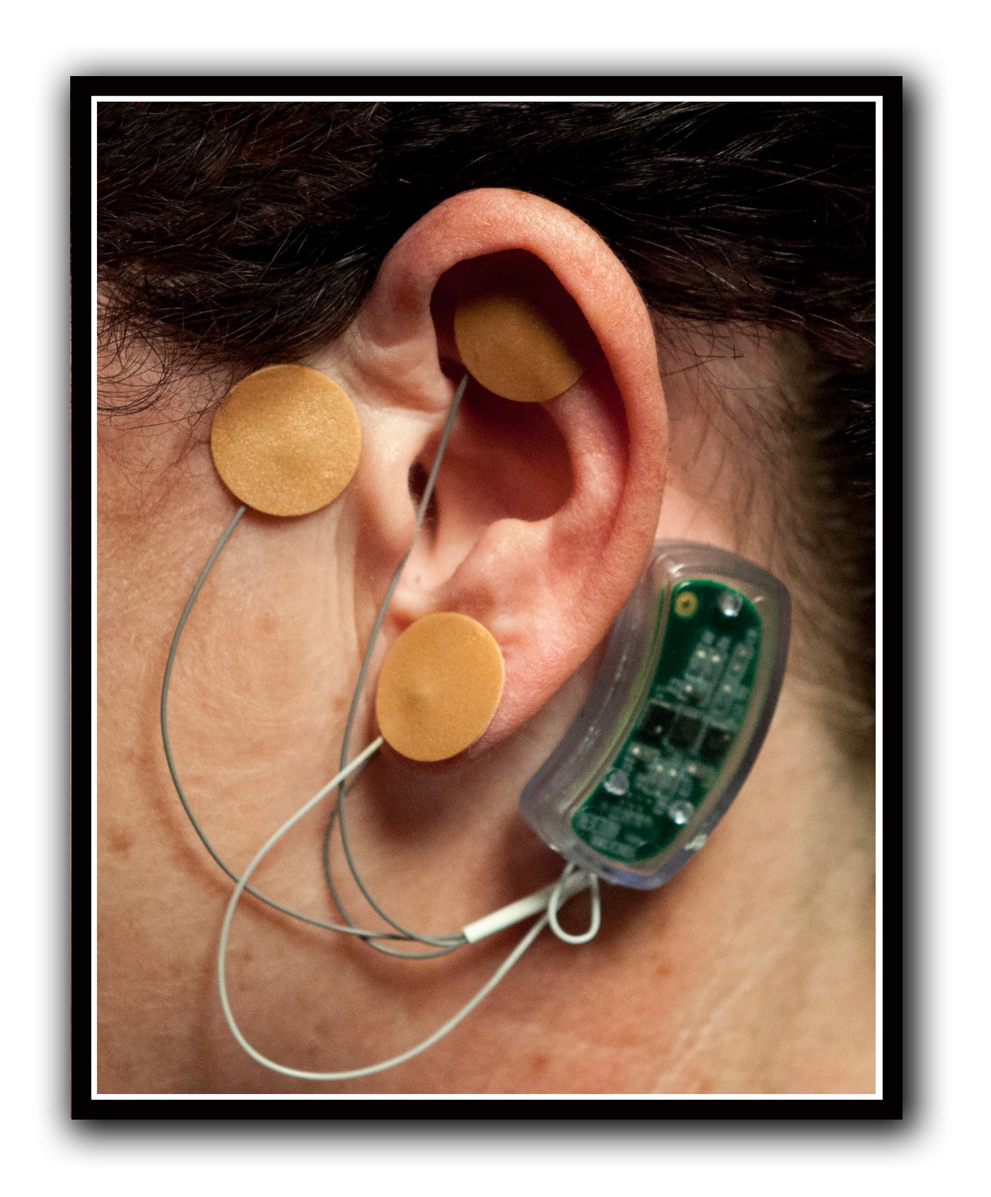

The external auricle is rich with branches of cranial nerves V,VII,IX,and X, branches of the Lesser and Greater Occipital Nerves of the upper cervical plexus the Superficial Temporal Artery (STA) , and the Posterior Auricular Artery (PAA). Evidence suggests the mechanism of action of auricular stimulation by the Bridge © occurs via activation of the nucleus tractus solitarious (NTS), the hypothalamus, the amygdala, and the rostral ventromedial medulla (RVM), affecting both sympathetic and parasympathetic feedback loops into the gray matter of the dorsal horn of the spinal column. The results are a disruption of ascending nociceptive stimuli and blocking of descending signals releasing endogenous endorphins and other cytokines often associated with hyperactivity of the previously mentioned entities during opiate withdrawal.

The Bridge © reduces sympathetic activity and increases parasympathetic activity by electrical stimulation of the associated cranial nerve bundles via percutaneous implantation of needle arrays into the dermis of the peri-auricular region. The Bridge © is designed to provide stimulation for a total of 120 hours allowing for physician applied ambulatory treatment of acute pain secondary to opiate withdrawal.

The Bridge © in conjunction with Vivatrol ® ( INSynergy-Bridge ) offers a non-narcotic option to opiate detox and also has the potential for shortening the transition from opioid use to Vivitrol® while minimizing withdrawal symptoms. The INSynergy-Bridge protocol may have particular utility regarding incarcerated individuals minimizing emergency department treatment and reducing costs secondary to withdrawal symptoms.
Clinical Design
All patients involved treated were in the acute phase of heroin or opiate withdrawal as verified by the Clinical Opiate Withdrawal Scale (COWS), a reliable and valid self-report assessment tool for measurement of opiate withdrawal symptoms. (4)
Data was collected on 8 cases. Six had addiction to prescription opiate pain medications and two had heroin addiction. Four were men and four were women and all were Caucasian, with a mean age of 33.2 years (SD = 7.1). All patients were in moderate to moderately-severe withdrawal based on COWS scale. The Bridge device was implanted and patients were observed in the clinic for at least one hour before being sent home. Medications were not given in the clinic in order to observe acute Bridge device effects. However patients were given the traditional non-narcotic rescue medications to take at home per request.
Results
Pre-post COWS data were available for 7/8 patients (one missing post-test). The pre-test mean COWS of 21.9 (SD = 5.5) was significantly reduced at post-test to 6.1 (SD = 5.2), t(6) = 5.5, p = .0015. However, the post-test for one of these patients was obtained the following day. Of the 6 patients for whom COWS data were obtained in clinic, after a mean interval of 32.5 minutes (SD = 14.7), mean COWS scores were 23.1 (SD = 5.1) at pre-test and 5.9 (SD = 5.6) at post-test, t(5) = 5.7, p = .0024. Time to Vivitrol treatment data were available for 7/8 patients (one pending): 4/7 patients (57%) transitioned to Vivitrol in less than 7 days (mean = 3.1 days, SD = 0.8). The remaining 3 patients were non-compliant with follow-up, resulting in times to Vivitrol of 12, 28, and 140 days. Clinical questioning also indicated that, in addition to significant reduction in COWS scores, patients experienced an improvement of overall mood, decreased sense of distress, and reduction of non-pain symptoms such as goose pimples, rhinorrhea, and restlessness (consistent with stimulation of the para-sympathetic tone). There were no adverse effects associated with the device.

Discussion
The Bridge © device was associated with a significant reduction in opiate withdrawal symptoms. Since heroin or opiate withdrawal is a combination of opiate receptor dysfunction and a hyperactive sympathetic nervous system, indications are the Bridge © device stimulates para-sympathetic activity via auricular neuro-vascular bundles containing cranial Nerve’s V, XII, IX and X, and localized cervical nerves reducing hyper-excitability motor states associated with adrenergic tone as well as stimulating endogenous endorphins to relieve pain symptoms associated with opiate withdrawal. The average time of the reduction of the COWS scores of 32.5 minutes may be the result of the nucleus tractus solitarius (NTS) relaying signals to the amygdala and the rostral ventral medulla (RVM) and associated spinal wind-up. Biochemical and pharmacological evidence provide support for the involvement of the noradrenergic system in the expression of the somatic symptoms during opiate withdrawal reporting changes in brain noradrenaline and metabolite levels during opiate dependence. (1)

During opiate withdrawal, the sympathetic nervous system becomes hyperactive and the hypothalamus, the pituitary gland, and the locus coeruleus begin working at above normal levels increasing activity of the peripheral sympathetic nervous system (SNS) as measured by increases in plasma levels of norepinephrine. (5)

Compensatory dysregulation of the sympathetic nervous system co-joined with the hypothalamic-pituitary-adrenal axis, the periaqueductal gray (PAG) area, the amygdala, the ventral tegmental area, nucleus accumbens, and spinal cord lead to an excess of bodily functions normally inhibited by opiates which often include pupils becoming abnormally large (miosis). Mouths which were overly dry begin overproducing saliva (mydriasis ), dry skin begins to perspire, dry noses begins to run, and insensitivity to temperature developing quickly into hot/cold flashes and chills and precipitation of the physical motor components of opiate withdrawal (6)

These fluctuations also contribute to excess cortisol release, emotional vulnerability, an inability to fall asleep, anxiety, agitation, panic attacks, increased heart rate, increased blood pressure, muscle tension, tremors, restlessness ( akathisia ), involuntary movements of the limbs, nausea, vomiting, and stomach discomfort. (7,8)

Other commonly observed symptoms such as diarrhea and lacrimation may be dependent on peripheral opiate receptors. (9)

In the peripheral nervous system (PNS), beta-endorphins produce analgesia by binding to opioid receptors (particularly of the mu subtype) at both pre- and post- synaptic nerve terminals, primarily exerting their effect through presynaptic binding. When bound, a cascade of interactions results in inhibition of the release of tachykinins, particularly substance P, a key protein involved in the transmission of pain contributing to allodynia and hyperalgesia commonly experienced during opiate withdrawal. (10,11,12,13,14,16,15)

Conclusion
The results from this clinical report of findings suggests the use of peri-auricular percutaneous electrical nerve nerve field stimulation (PENFS), the Bridge © is a potentially efficacious avenue helping reduce symptoms often associated with opioid withdrawal as measured by the COWS scores. Combining the Bridge © and Vivitrol ® into the INSynergy-Bridge protocol shows promise for treatment of opioid addiction.
The financial cost of incarceration of drug addicted offenders is estimated at over $48 billion dollars. (16) While more comprehensive, randomized, sham-controlled studies are needed to further establish efficacy, initial clinical use of the Bridge © indicates a viable option for pain reduction during the transition from opioids increasing compliance and potentially reducing jail crowding and incarceration costs.
________________________________________
* Dr. Arturo Taca is a Diplomate of the American Board of Addiction Medicine practicing in St. Louis , Missouri. He specializes in outpatient substance abuse implementing technologies to treat addiction and its related conditions. He has no financial interest in the Bridge ® or Innovative Health Solutions.

Bibliography
- Kolodny, A., Courtwright, D. T., Hwang, C. S., Kreiner, P., Eadie, J. L., Clark, T. W., & Alexander, G. C. (2015). The prescription opioid and heroin crisis: a public health approach to an epidemic of addiction. Annual review of public health, 36, 559-574.
- Rieckmann, T., Garvey, K. T., Srikanth, P., Andrich, L., & Gregg, J. (2015). The Vivitrol pilot program (VPP): initial quantitative findings from an extended-release naltrexone study. Addiction science & clinical practice, 10(1), 1.
- Roberts A, Brown C. Decrease in VAS Score Following Placement of a Percutaneous Peri-Auricular Peripheral Nerve Field Stimulator. Clinical Medicine and Diagnosis. 2015. 5(2): 17-21. DOI: 10.5923/j.cmd.20150502.01
- Barbosa-Leiker, C., McPherson, S., Mamey, M. R., Burns, G. L., Layton, M. E., Roll, J., & Ling, W. (2015). Examining the factor structure of the Clinical Opiate Withdrawal Scale: A secondary data analysis from the National Drug Abuse Treatment Clinical Trials Network (CTN) 0003. Drug and alcohol dependence, 152, 218-223.
- Maldonado R., Neurosci Biobehav Rev. 1997 Jan;21(1):91-104. Participation of noradrenergic pathways in the expression of opiate withdrawal: biochemical and pharmacological evidence.
- A. A. McPhie and G. A. Barr, “Regional Fos expression induced by morphine withdrawal in the 7-day-old rat,” Developmental Psychobiology, vol. 51, no. 7, pp. 544–552, 2009.
- R. Maldonado, L. Stinus, L. H. Gold, and G. F. Koob, “Role of different brain structures in the expression of the physical morphine withdrawal syndrome,” Journal of Pharmacology and Experimental Therapeutics, vol. 261, no. 2, pp. 669–677, 1992.
- G. F. Koob, R. Maldonado, and L. Stinus, “Neural substrates of opiate withdrawal,” Trends in Neurosciences, vol. 15, no. 5, pp. 186–191, 1992.
- Brain Res. 1980 Feb 10;183(2):301-11.
- Crawley JN, Maas JW, Roth RH.Evidence against specificity of electrical stimulation of the nucleus locus coeruleus in activating the sympathetic nervous system in the rat.
- Miller R. Miller's Anesthesia. 6th ed. Pennsylvania: Elsevier; 2005. pp. 382–386.
- Brunton L. Goodman and Gilman's The Pharmacological Basis of Therapeutics. 11th ed. New York: McGraw-Hill; 2006. pp. 547–559.
- DuPen A, Shen D, Ersek M. Mechanisms of Opioid-Induced Tolerance and Hyperalgesia. Pain Management Nurs. 2007;8(3):113–121
- The Neurobiology of Opioid Dependence: Implications for Treatment. Thomas R. Kosten, M.D. and Tony P. George, M.D.
- Rasmussen K. Afferent Effects on Locus Coeruleus in Opiate Withdrawal. Progress in Brain Research.1991. Vol. 88: 207-216. Doi 10.1016/S0079-6
- Zarkin, G. A., Cowell, A. J., Hicks, K. A., Mills, M. J., Belenko, S., Dunlap, L. J., & Keyes, V. (2015). Lifetime benefits and costs of diverting substance-abusing offenders from state prison. Crime & Delinquency, 61(6), 829-850.

